2021 IANA Numbering Services Review Committee Report
Date: 10 March 2022

Introduction

Background
In 2016, the Internet Number Community (“The Community”) proposal to the IANA Stewardship Coordination Group (“ICG”) on the IANA Stewardship Transition called for a review committee to be established. The committee was to be comprised of community representatives from each Regional Internet Registry (“RIR”) region. Their function is intended to advise RIRs on the IANA Functions Operator’s performance and adherence to the Service Level Agreement (“SLA”).
The IANA Numbering Services Review Committee (“RC”) was established in October 2016 with representatives from all five RIR regions.

About the IANA Numbering Services Review Committee

Role of The Committee
The RC’s role is to advise and assist the Number Resource Organization Executive Committee (“NRO EC”) in a periodic review of SLA compliance for the IANA-supplied Numbering Services (“The Services”) provided to The Community.
The RC submits an annual report of its findings to the NRO EC.

Website and Proceedings
The RC website and proceedings including meeting archives are found at: https://www.nro.net/iana-numbering-services-review-committee/

Charter
The charter of the RC is found at: https://www.nro.net/review-committee-charter-final

Composition and Members of the RC
The RC is comprised of three representatives from each RIR region.

AFRINIC:
- Saul Stein– Community
- Mike Silber – Community
- Madhvi Gokool – RIR Staff

APNIC:
- Ching-Heng Ku – Community
- Satoru Tsurumaki – Community
- Guangliang Pan – RIR Staff

ARIN:
- Chris Quesada – Community
- Martin Hannigan – Community (Chair)
- John Sweeting – RIR Staff

LACNIC:
- Nathalia Sautchuk Patrício – Community (Vice-Chair)
- Sergio Rojas – Community
- Ernesto Majó – RIR Staff

RIPE:
- James Kennedy – Community
- Sander Steffann – Community
- Marco Schmidt – RIR Staff

Methodology

Period Covered
This review covers The Services delivered during the previous operating year, which was January 1, 2021, through December 31, 2021.

Community Input
The RC openly sought Internet number community input on the Services SLA performance through a 30-day comment period following the posting of the RIR review matrix through email to iana-performance@nro.net.
Notice of the 30-day comment period was publicly posted on the NRO Website, and announced on the five RIR announcement mailing lists:
- AFRINIC: announce@afrinic.net
- APNIC: apnic-announce@lists.apnic.net
- ARIN: arin-announce@arin.net
- LACNIC: anuncios@lacnic.net
- RIPE: ripe-list@ripe.net
(See Appendix 2 for links to each announcement message.)
RC members are encouraged to interact with their respective communities about The Services.

Data Sets

RIR IANA Numbering services review Matrix
RIR review Matrix: https://www.nro.net/2021-IANA-Performance-Matrix-Summary-Report
Monthly IANA reports:
https://www.iana.org/performance/numbers
RIR summary of The Services operator’s annual performance from RIR Matrix:
The Regional Internet Registry (RIR) staff have reviewed the IANA performance reports for 2021 and confirm that the Service Level Agreements (SLA) were met 100% of the time in all cases. The three AS number requests submitted during May, October, and November fully met the expectations of the RIRs and were executed within the agreed terms of our SLA with no issues to note. The RIRs recognize the flawless execution of IANA services in 2021.​

Community Input Regarding the Services Matrix
The RC notes that no comments were received during the public comment period.

Conclusion
The RC evaluated the data sets in Section 3 and observed that:
- Three ASN allocations were requested – one in May and one October by APNIC, and one in November by LACNIC.
All requests were fulfilled accurately and on time.
There have been no reported or observed issues related to The Services operator’s ability to meet its obligations under the SLA.
The Internet numbers community has not raised concerns regarding the SLA compliance of The Services operator or its ability to perform its function.
The RC reports sufficient community outreach and community involvement supporting and enhancing the multistakeholder model in a transparent, open, and bottom-up process in its review of The Services operator.
The RC concludes that the performance of the IANA Number Services Operations is within the SLA and requires no further examination.

References
- IANA Numbering Services Review Committee website: https://www.nro.net/iana-numbering-services-review-committee/
- IANA number resource services performance reports: https://www.iana.org/performance/numbers
- RIR IANA Numbering Services Review Matrix: https://www.nro.net/2021-IANA-Performance-Matrix-Summary-Report
- The Service Level Agreement (SLA) for the IANA Numbering Services: https://www.nro.net/sla
- The IANA Stewardship Transition Proposal: https://www.ianacg.org/icg-files/documents/IANA-transition-proposal-final.pdf

Appendices

Appendix 1. RIR IANA Numbering Services Review Matrix
https://www.nro.net/2021-IANA-Performance-Matrix-Summary-Report

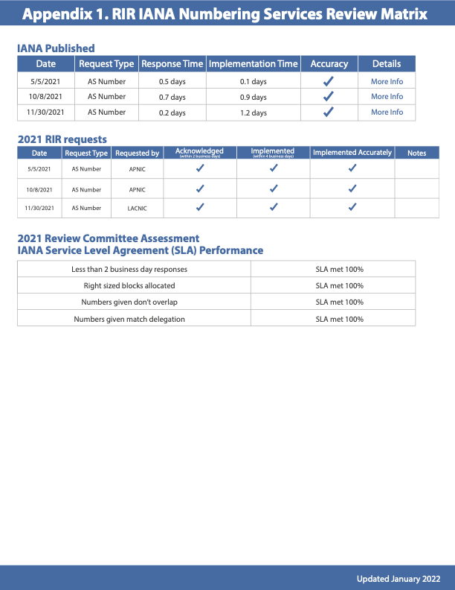

Appendix 2. Community input
Notice of the 30-day comment period was publicly posted on the NRO website, and announced on the appropriate RIR announcement mailing lists:
- NRO announcement: https://www.nro.net/call-for-public-comments-on-the-2021-iana-performance-matrix-summary-report/
- AFRINIC announcement: https://lists.afrinic.net/pipermail/announce/2022/002328.html
- APNIC announcement: https://mailman.apnic.net/hyperkitty/list/apnic-announce@apnic.net/thread/P6FYEHMQTEAQOQISQKDW4NFI2DBR6TZX/
- ARIN announcement: https://lists.arin.net/pipermail/arin-announce/2022-February/002616.html
- LACNIC announcement: https://mail.lacnic.net/pipermail/anuncios/2022-February/001362.html
- RIPE announcement: https://www.ripe.net/ripe/mail/archives/ripe-list/2022-February/002447.html

