2021 IANA Numbering Services Review Committee Report
Date: 10 March 2022

Introduction

Background
In 2016, the Internet Number Community (“The Community”) proposal to the IANA Stewardship Coordination Group (“ICG”) on the IANA Stewardship Transition called for a review committee to be established. The committee was to be comprised of community representatives from each Regional Internet Registry (“RIR”) region. Their function is intended to advise RIRs on the IANA Functions Operator’s performance and adherence to the service level agreement (“SLA”).
The IANA Numbering Services Review Committee (“RC”) was established in October 2016 with representatives from all five RIR regions.

About the IANA Numbering Services Review Committee

Role of The Committee
The RC’s role is to advise and assist the Number Resource Organization Executive Committee (“NRO EC”) in a periodic review of SLA compliance for the IANA-supplied Numbering Services (“The Services”) provided to The Community.
The RC submits an annual report of its findings to the NRO EC.

Website and Proceedings
The RC website and proceedings including meeting archives are found at: https://www.nro.net/iana-numbering-services-review-committee/

Charter
The charter of the RC is found at: https://www.nro.net/review-committee-charter-final

Composition and Members of the RC
The RC is comprised of three representatives from each RIR region.

AfriNIC:
- Saul Stein– Community
- Mike Silber – Community
- Madhvi Gokool – RIR Staff

APNIC:
- Bertrand Cherrier – Community
- Satoru Tsurumaki – Community
- Guangliang Pan – RIR Staff

ARIN:
- Chris Quesada – Community
- Martin Hannigan – Community (Chair)
- John Sweeting – RIR Staff

LACNIC:
- Nathalia Sautchuk Patrício – Community
- Sergio Rojas – Community
- Ernesto Majó – RIR Staff

RIPE:
- Filiz Yilmaz – Community
- Nurani Nimpuno – Community (VICE CHAIR)
- Marco Schmidt - RIR Staff

Methodology

Period Covered
This review covers The Services delivered during the previous operating year, which was January 1, 2021, through December 31, 2021.

Community Input
The RC openly sought Internet number community input on the Services SLA performance through a 30-day comment period following the posting of the RIR review matrix through email to iana-performance@nro.net.
Notice of the 30 day comment period was publicly posted on the NRO web site, and announced on the five RIR announcement mailing lists:
- AfriNIC: announce@afrinic.net
- APNIC: apnic-announce@lists.apnic.net
- ARIN: arin-announce@arin.net
- LACNIC: anuncios@lacnic.net
- RIPE: ripe-list@ripe.net
(See Appendix 2 for links to each announcement message.)
RC members are encouraged to interact with their respective communities about The Services.

Data Sets

RIR IANA Numbering services review Matrix
RIR review Matrix: https://www.nro.net/wp-content/uploads/2020-RIR-IANA-summary-report.pdf
Monthly IANA reports:
https://www.iana.org/performance/numbers
RIR summary of The Services operator’s annual performance from RIR Matrix:
The Regional Internet Registry (RIR) staff have reviewed the IANA performance reports for 2020 and confirm that the Service Level Agreements (SLA) were met 100% of the time in all cases. The five AS number requests submitted during March, May, October, and November fully met the expectations of the RIRs and were executed within the aagreedtoterms of our SLA with no issues to note. The RIRs recognize the flawless execution of IANA services in 2020.​

Community Input Regarding the Services Matrix
The RC notes that one comment was received in the public comment period supporting the conclusion that the SLAs for the IANA numbering services have been met 100%.
The full comment is included in Appendix 2.

Conclusion
The RC evaluated the Data sets in Section 3 and observed that:
- Five ASN allocations were requested – one during March by AFRINIC, one during March by RIPE NCC, one during May by LACNIC, one during October by APNIC, and one during November by ARIN.
All requests were fulfilled accurately and on time.
There have been reported or observed issues related to The Services operator’s ability to meet its obligations under the SLA.
The Internet numbers community has not raised concerns regarding the SLA compliance of The Services operator or its ability to perform its function.
The RC reports sufficient community outreach and community involvement supporting and enhancing the multistakeholder model in a transparent, open, and bottom-up process in its review of The Services operator.
The RC concludes that the performance of the IANA Number Services Operations is within the SLA and requires no further examination.

References
- IANA Numbering Services Review Committee website: https://www.nro.net/iana-numbering-services-review-committee/
- IANA number resource services performance reports: https://www.iana.org/performance/numbers
- RIR IANA Numbering Services Review Matrix: https://www.nro.net/wp-content/uploads/2020-RIR-IANA-summary-report.pdf
- The Service Level Agreement (SLA) for the IANA Numbering Services: https://www.nro.net/wp-content/uploads/SLA-Executed-ICANN-RIRS.pdf
- The IANA Stewardship Transition Proposal: https://www.ianacg.org/icg-files/documents/IANA-transition-proposal-final.pdf
- Community input on RIR IANA Numbering services review Matrix:
https://nro.net/pipermail/iana-performance/2021-February/000001.html

Appendices

Appendix 1. RIR IANA Numbering Services Review Matrix
https://www.nro.net/wp-content/uploads/2020-RIR-IANA-summary-report.pdf

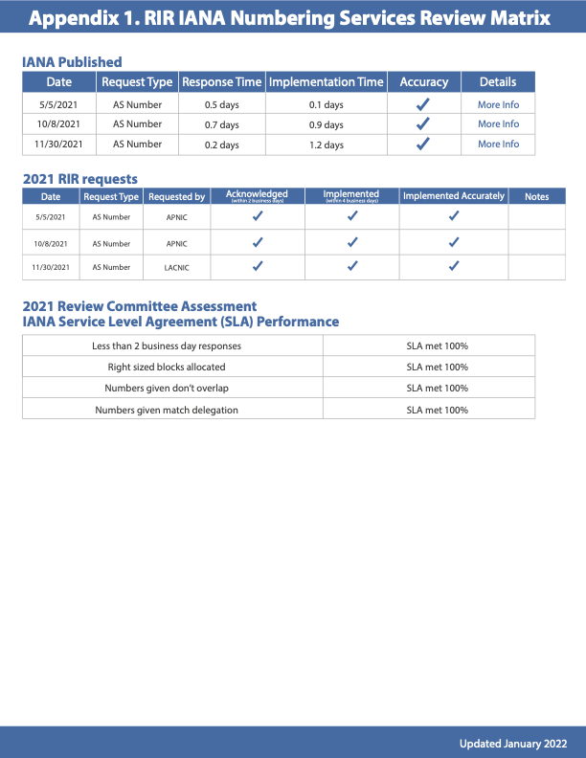

Appendix 2. Community input
Notice of the 30 day comment period was publicly posted on the NRO website, and announced on the appropriate RIR announcement mailing lists:
- NRO announcement: https://www.nro.net/call-for-public-comments-on-the-2020-iana-performance-matrix-summary-report/
- AFRINIC announcement: https://lists.afrinic.net/pipermail/announce/2021/002266.html
- APNIC announcement: https://mailman.apnic.net/mailing-lists/apnic-announce/archive/2021/02/msg00001.htm
- ARIN announcement: https://lists.arin.net/pipermail/arin-announce/2021-March/002505.html
- LACNIC announcement: https://mail.lacnic.net/pipermail/anuncios/2021-February/001334.html
- RIPE announcement: https://www.ripe.net/ripe/mail/archives/ripe-list/2021-February/002003.html

All collected community comments in a raw, unedited format can be found online:
https://nro.net/pipermail/iana-performance/2021-February/000001.html
These comment(s) are also included below: (Personally identifiable information has been redacted.)

Comment 1:
From: Lars-Johan [email redacted]
Date: Mon Feb 8 13:20:07 CET 2021
Subject: [Iana-performance] Positive feedback on the 2020-RIR-IANA-summary-report.

Hello!

I happen to be both a RIPE member and the current chair of the ICANN
Customer Standing Committee that audits the PTI when it comes to its
performance as administrators of the DNS root zone.

I'd just like to concur with your assent for the PTI and their work to
fulfill the IANA contract. See this as a "+1" from me. Your summary
matches quite well what we in the CSC see on the domain name side. We
see "100 %" all over the field, with only the occasional minor breach.
Those are counted in the singles, and in most cases, it's down to SLAs
that weren't thoroughly tested before being put into operation.

We also find the PTI very approachable and accomodating, and we have a
very good dialogue with them.

If you and the NRO community share my positive views, I hope you share
them also with the PTI. It's easy to forget to convey appreciation for
good work and to focus only on criticizing when improvement is needed.

Best regards,
/Lars-Johan Liman
--
#----------------------------------------------------------------------
# Lars-Johan Liman, M.Sc. ! E-mail: [email redacted]
# Senior Systems Specialist ! Tel: [phone redacted]
# Netnod Internet Exchange, Stockholm ! http://www.netnod.se/
#----------------------------------------------------------------------

