2024 IANA Numbering Services

Review Committee Report
The IANA Review Committee
3 March 2025

Introduction
In 2016, the Internet Number Community (”the “Number Community”) proposal to the IANA Stewardship Coordination Group (“ICG”) on the IANA Stewardship Transition (the “Number Community Proposal”) called for a review committee to be established. The committee was to be comprised of community representatives from each Regional Internet Registry (“RIR”) region. The committee was to advise RIRs on the IANA Functions Operator’s performance of the IANA Numbering Services and adherence to the Service Level Agreement (“SLA”) between the IANA Numbering Services Operator and the RIRs (as defined in the Number Community Proposal).
The IANA Numbering Services Review Committee (“RC”) was established in October 2016 for that purpose with representatives from all five RIR regions.

Summary
We, the RC, conclude that the performance of the IANA Numbering Services Operator related to delivery of the IANA Numbering Services and performance under the SLA in 2024 was acceptable. See Section 4 for discussion regarding review materials and their evaluation.

The Role of the IANA Numbering Services Review Committee
Our role is to advise and assist the Number Resource Organization Executive Committee (“NRO EC”) in a periodic review of SLA compliance for the IANA Numbering Services provided to the Number Community.
The RC submits an annual report of its findings to the NRO EC.

Website and Proceedings
The RC’s website and proceedings, including meeting archives, can be accessed at: https://www.nro.net/iana-numbering-services-review-committee/

Charter
The RC’s charter can be accessed at: https://www.nro.net/review-committee-charter-final

Composition and Members of the RC
The RC is comprised of three representatives from each RIR region.

AFRINIC
- Madhvi Gokool – RIR Staff

APNIC
- Ching-Heng Ku – Community
- Dibya Khatiwada – Community
- Vivek Nigam – RIR Staff

ARIN
- Amy Potter – Community
- Nick Nugent – Community
- John Sweeting – RIR Staff

LACNIC
- Nathalia Sautchuk Patrício – Community
- Lia Solis – Community
- Alfredo Verderosa – RIR Staff

RIPE
- Constanze Bürger – Community
- Andrei Robachevsky – Community
- Marco Schmidt – RIR Staff

Methodology

Period Covered
This review covers the IANA Numbering Services delivered during the previous operating year, which was January 1, 2024, through and including December 31, 2024.

Community Input
The RC sought Number Community input on the SLA performance through a 30-day public comment period following the posting of the review matrix via email to iana-performance@nro.net. Notice of the 30-day comment period was also posted publicly on the NRO Website and announced on all five RIR announcement email lists:
- AFRINIC: announce@afrinic.net
- APNIC: apnic-announce@lists.apnic.net
- ARIN: arin-announce@arin.net
- LACNIC: anuncios@lacnic.net
- RIPE: ripe-list@ripe.net
(See Appendix 2 for links to each announcement message.)
RC members are encouraged to interact with their respective communities about the IANA Numbering Services.

Data Sets

RIR IANA Numbering Services Review Matrix

Matrix: https://www.nro.net/wp-content/uploads/2024-IANA-Performance-Matrix-Final.pdf
Monthly IANA reports:
https://www.iana.org/performance/numbers
RIR summary of IANA Numbering Services Operator’s annual performance: RIR staff have reviewed the IANA performance reports for 2024 and confirm that the SLA was met 100% of the time in all cases. We note no comments were received during the public comment period.

Conclusion

In reaching our conclusion that the SLA was met, we evaluated the data sets noted in Section 4.3 and reviewed the SLA requirements.
We observed that a total of two (2) ASN allocations were requested: one (1) in March by LACNIC and one (1) in April by ARIN. In addition, one (1) IPv6 Unicast [address block] was requested by APNIC. No other requests were made. No issues were observed related to IANA Numbering Services Operator’s ability to deliver or perform the IANA Numbering Services and comply with the SLA. We observed sufficient community outreach and involvement during review of the IANA Numbering Services Operator and its performance.

References
- IANA Numbering Services Review Committee website: https://www.nro.net/iana-numbering-services-review-committee/
- IANA number resource services performance reports: https://www.iana.org/performance/numbers
- RIR IANA Numbering Services Review Matrix: https://www.nro.net/wp-content/uploads/2024-IANA-Performance-Matrix-Final.pdf
- The Service Level Agreement for the IANA Numbering Services: https://www.nro.net/sla
- The IANA Stewardship Transition Proposal: https://www.ianacg.org/icg-files/documents/IANA-transition-proposal-final.pdf

Appendices

Appendix 1. RIR IANA Numbering Services Review Matrix
https://www.nro.net/2023-IANA-Performance-Matrix-Summary-Report
https://www.nro.net/wp-content/uploads/2024-IANA-Performance-Matrix-Final.pdf

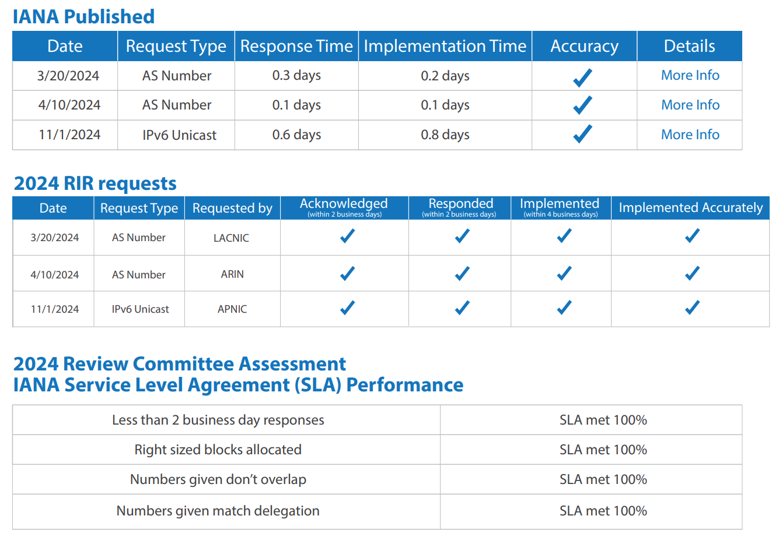

Appendix 2. Community input
Notice of the 30-day comment period was publicly posted on the NRO website. It was also announced on the respective RIR announcement mailing lists. Links to access those announcements on the web are provided below.

- NRO announcement: https://www.nro.net/call-for-public-comments-on-the-2024-iana-performance-matrix-summary-report/
- AFRINIC announcement: https://lists.afrinic.net/pipermail/announce/2025/002439.html
- APNIC announcement: https://orbit.apnic.net/hyperkitty/list/apnic-talk@lists.apnic.net/thread/3MVM76UNNEBT3VR5EVJQWYQWOSCV2TXF/#3MVM76UNNEBT3VR5EVJQWYQWOSCV2TXF
- ARIN announcement: https://lists.arin.net/pipermail/arin-announce/2025-January/002915.html
- LACNIC announcement: https://mail.lacnic.net/pipermail/anuncios/2025-January/001437.html
- RIPE announcement: https://www.ripe.net/about-us/news/iana-public-comment-2025/

