2021 IANA Numbering Services

Review Committee Report
The IANA Review Committee
March 10, 2022

Introduction
In 2016, the Internet Number Community (“The Community”) proposal to the IANA Stewardship Coordination Group (“ICG”) on the IANA Stewardship Transition called for a review committee to be established. The committee was to be comprised of community representatives from each Regional Internet Registry (“RIR”) region. Their function is intended to advise RIRs on the IANA Functions Operator’s performance and adherence to the Service Level Agreement (“SLA”).
The IANA Numbering Services Review Committee (“RC”) was established in October 2016 with representatives from all five RIR regions.

Summary
We conclude the performance of the IANA Number Services Operator related to delivery of The Services and the SLA is acceptable. See Section 4 for discussion regarding review materials and their evaluation.

The Role of The IANA Numbering Services Review Committee
Our role is to advise and assist the Number Resource Organization Executive Committee (“NRO EC”) in a periodic review of SLA compliance for the IANA-supplied Numbering Services (“The Services”) provided to The Community.
The RC submits an annual report of its findings to the NRO EC.

Website and Proceedings
The RC’s website and proceedings including meeting archives can be accessed at: https://www.nro.net/iana-numbering-services-review-committee/

Charter
The RC’s charter can be accessed at: https://www.nro.net/review-committee-charter-final

Composition and Members of the RC
The RC is comprised of three representatives from each RIR region.

AFRINIC
- Saul Stein– Community
- Mike Silber – Community
- Madhvi Gokool – RIR Staff

APNIC
- Ching-Heng Ku – Community
- Satoru Tsurumaki – Community
- Guangliang Pan – RIR Staff

ARIN
- Chris Quesada – Community
- Martin Hannigan – Community (Chair)
- John Sweeting – RIR Staff

LACNIC
- Nathalia Sautchuk Patrício – Community (Vice Chair)
- Sergio Rojas – Community
- Ernesto Majó – RIR Staff

RIPE
- James Kennedy – Community
- Sander Steffann – Community
- Marco Schmidt – RIR Staff

Methodology

Period Covered
This review covers The Services delivered during the previous operating year, which was January 1, 2021, through and including December 31, 2021.

Community Input
The RC sought Internet number community input on the Services SLA performance through a 30-day public comment period following the posting of the review matrix via email to iana-performance@nro.net. Notice of the 30-day comment period was also posted publicly on the NRO Website and announced on all five RIR announcement email lists:
- AFRINIC: announce@afrinic.net
- APNIC: apnic-announce@lists.apnic.net
- ARIN: arin-announce@arin.net
- LACNIC: anuncios@lacnic.net
- RIPE: ripe-list@ripe.net
(See Appendix 2 for links to each announcement message.)
RC members are encouraged to interact with their respective communities about The Services.

Data Sets

RIR IANA Numbering Services Review Matrix

RIR review Matrix: https://www.nro.net/2021-IANA-Performance-Matrix-Summary-Report
Monthly IANA reports:
https://www.iana.org/performance/numbers
RIR summary of The Services operator’s annual performance: Regional Internet Registry (RIR) staff have reviewed the IANA performance reports for 2021 and confirm that the Service Level Agreements (SLA) were met 100% of the time in all cases. We note no comments were received during the public comment period.

Conclusion

In reaching our conclusion that The Services SLA was met, we evaluated the data sets noted in Section 3 and reviewed the SLA requirements.
We observed a total of three (3) ASN allocations were requested. One (1) in May and one (1) in October by APNIC. One (1) was also made in November by LACNIC. None were made by other registries. No issues were observed related to The Services operator’s ability to deliver or perform The Services and comply with the SLA. We observed sufficient community outreach and involvement during review of The Services operator and their performance.

References
- IANA Numbering Services Review Committee website: https://www.nro.net/iana-numbering-services-review-committee/
- IANA number resource services performance reports: https://www.iana.org/performance/numbers
- RIR IANA Numbering Services Review Matrix: https://www.nro.net/2021-IANA-Performance-Matrix-Summary-Report
- The Service Level Agreement (SLA) for the IANA Numbering Services: https://www.nro.net/sla
- The IANA Stewardship Transition Proposal: https://www.ianacg.org/icg-files/documents/IANA-transition-proposal-final.pdf

Appendices

Appendix 1. RIR IANA Numbering Services Review Matrix
https://www.nro.net/2021-IANA-Performance-Matrix-Summary-Report

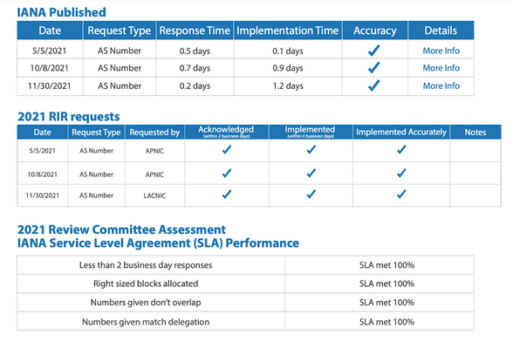

Appendix 2. Community input
Notice of the 30-day comment period was publicly posted on the NRO website. It was also announced on the respective RIR announcement mailing lists. Links to access those announcements on the web are provided below.

- NRO announcement: https://www.nro.net/call-for-public-comments-on-the-2021-iana-performance-matrix-summary-report/
- AFRINIC announcement: https://lists.afrinic.net/pipermail/announce/2022/002328.html
- APNIC announcement: https://mailman.apnic.net/hyperkitty/list/apnic-announce@apnic.net/thread/P6FYEHMQTEAQOQISQKDW4NFI2DBR6TZX/
- ARIN announcement: https://lists.arin.net/pipermail/arin-announce/2022-February/002616.html
- LACNIC announcement: https://mail.lacnic.net/pipermail/anuncios/2022-February/001362.html
- RIPE announcement: https://www.ripe.net/ripe/mail/archives/ripe-list/2022-February/002447.html

